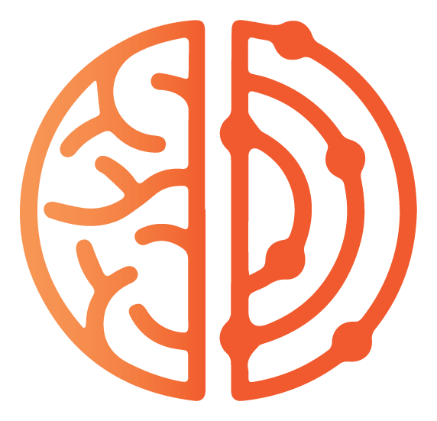 RW Institute

AI Working Labs: Wells Fargo PCI Pilot
Revised curriculum map for discussion RW Institute · June 11, 2026

All seven topics from the signed scope are still here. What changed is their shape. Instead of one topic per session, each lab now produces a finished piece of real work, and the competencies that protect quality, accuracy, and safe data handling repeat inside every session until they become habits. Participants leave each week with something they can use, not just something they learned.

How every lab runs
- 90 minutes, live and recorded: a demonstration of one workflow on realistic practice data, an extended hands-on build block, and shared results. Everyone works in the Claude desktop app (Cowork) from a single working folder; a browser fallback covers anyone whose IT blocks the install.
- The data spine: participants export from their protected environment with identifying details removed, do the substantive work in frontier AI tools, then return results to their own systems where the details reassemble. Safe data handling gets practiced every week rather than taught once. The specific anonymization technique is a decision we make together; an options sheet accompanies this map.
- Buddy pairs, two per organization, work between sessions to finish real deliverables from their own backlog. Each pair builds a short list of things they actually need to produce this quarter, collected before Lab 1, and the labs help them ship it.
- Between-session work comes in three levels every week (roughly 30 minutes, 1 to 2 hours, or 3-plus hours), each with a stated output. Pairs choose based on their time and experience, and can choose differently each week. The deepest level builds toward the tools and agents shown at the final session.

The seven labs
 | Lab | What participants make | Scope topics covered
1 | First Safe Win | The full data round-trip on a real writing task. Everyone leaves with one usable output and the safety habit started. | AI Mindset & Foundations; Governance & Risk
2 | Writing + the Org Brain | Each pair builds a permanent project loaded with their organization's identity and voice, then produces real writing through it: grant applications, donor communications, memos. | Quality & Accuracy
3 | Board-Ready Reporting + the Second Chair | Messy inputs turned into polished narrative summaries, plus a critique pass that becomes a required step in everything that follows. | Reporting & Narrative Building
4 | Data: Clean & Extract | Spreadsheet cleanup and insight extraction on program data through the round-trip, with an auditable change log. | Metrics & Data Review
5 | Numbers to Narrative to Deck | Analysis becomes an impact story with verified figures, then a presentation. Includes visual judgment: what to chart, what to say in a sentence. | Metrics & Reporting, combined
6 | Agents & the Wider Toolbox | Each pair turns their critique pass into a standing reviewer agent, runs one supervised research-agent task, and learns which tools complement which. | Workflow Design; Governance applied
7 | Build Session & 90-Day Roadmap | Pairs assemble, document, and present the operational workflow they built across the program, then set 90-day priorities. | Workflow Design; Build Session & Roadmap

Where the other scope topics went
- Quality & Accuracy became a verification ritual inside every lab rather than a single session, deepening each week: source-tracing, the critique pass, spot-checks and reconciliation on data.
- Governance & Risk Awareness became the data round-trip itself, practiced weekly from Lab 1, plus a simple classification habit for deciding what data can travel and how.
- Bias awareness and communication risk management ride the critique pass: every adversarial review checks for missing perspectives, slanted sources, and the sentence that could be quoted out of context, from Lab 3 onward and explicitly in the agents lab.
- Workflow Design became the between-session arc: each week, buddy pairs complete one stage of their own workflow, so the final session is assembly rather than a cold start.

Before Lab 1
- A short intake gathers current tools, comfort levels, and the 3 to 5 real items each pair needs to produce this quarter.
- A setup guide walks every participant through installing the Claude desktop app and proving the file workflow end to end, with a browser fallback documented for anyone whose IT blocks the install. Wells Fargo participants may need IT approval for the install, so this goes out the day the cohort is confirmed.
- A technical pre-flight confirms working access for every participant so no session is lost to login problems.

What stays the same
Seven sessions over seven weeks at 90 minutes each, live and recorded, two cohorts of 25, and every participant finishing with at least one operational workflow. The structure below is a starting point; the pieces are built to move once we hear what the cohort actually needs.

